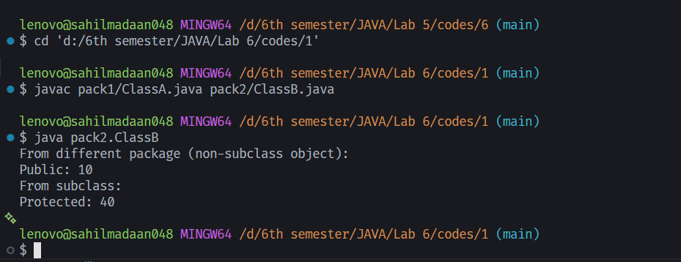
OUTPUT:

LAB 6
- create two different packages and demonstrate the accessibility of classes and their members using different access specifiers(public, private, default and protected)
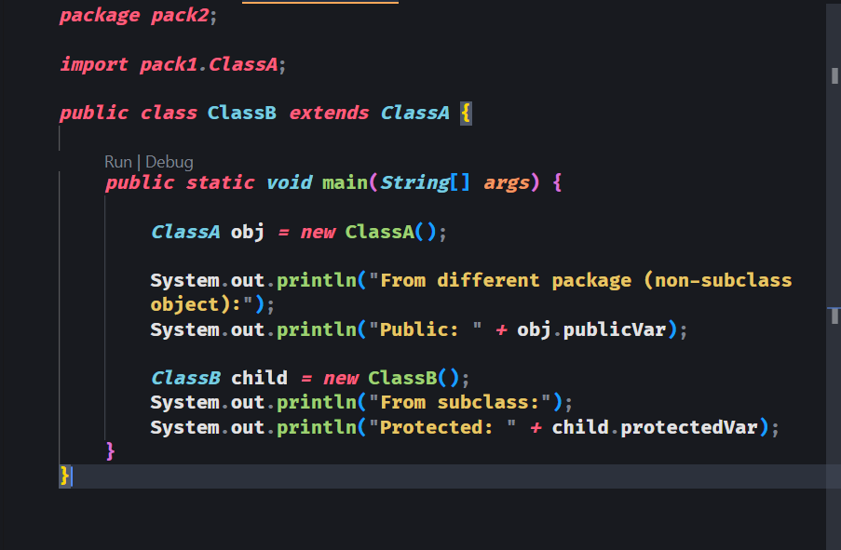

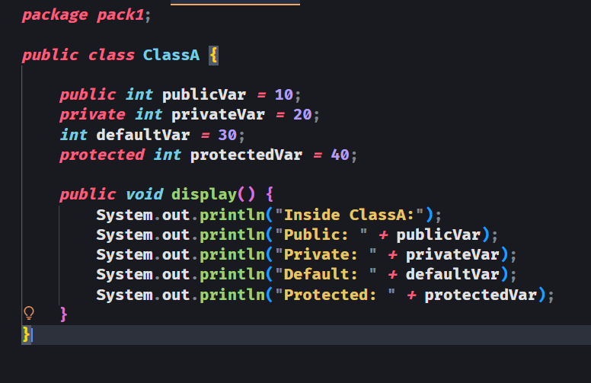

OUTPUT:
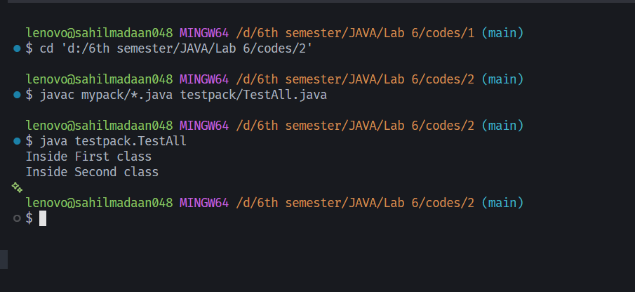

LAB 6
2. create a package containing multiple classes and demonstrate how to access them from another package using
(i). importing all classes(package.*)
(ii). importing specific classes
(iii). using fully qualified class name
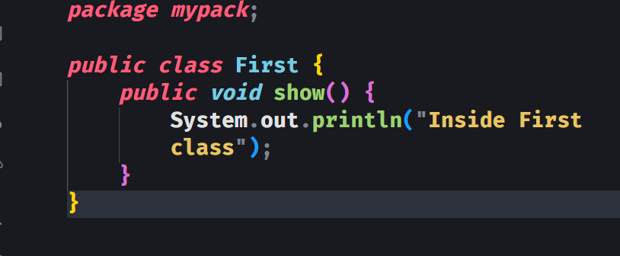

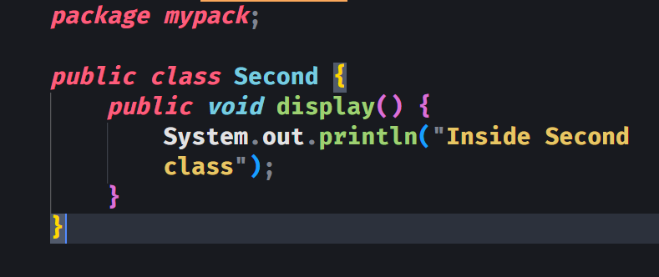

(i) Import All Classes
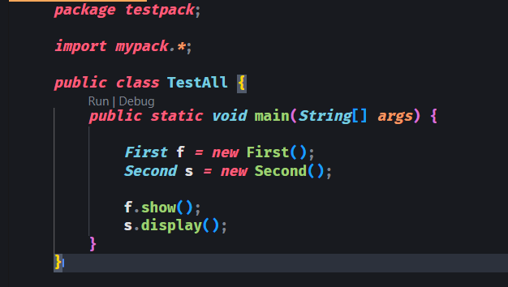

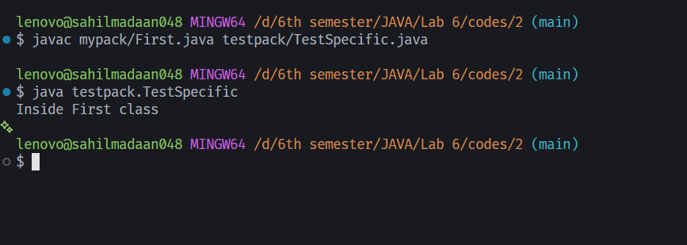
OUTPUT:

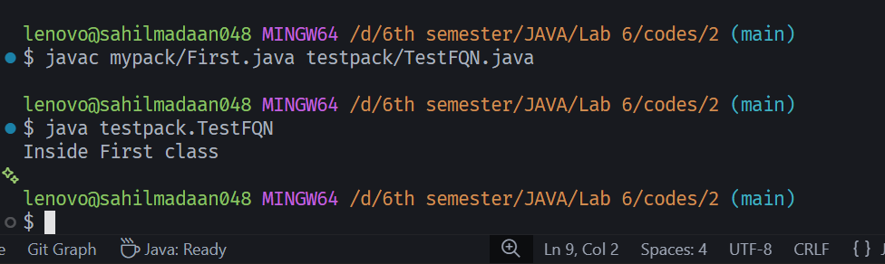

(ii). importing specific classes
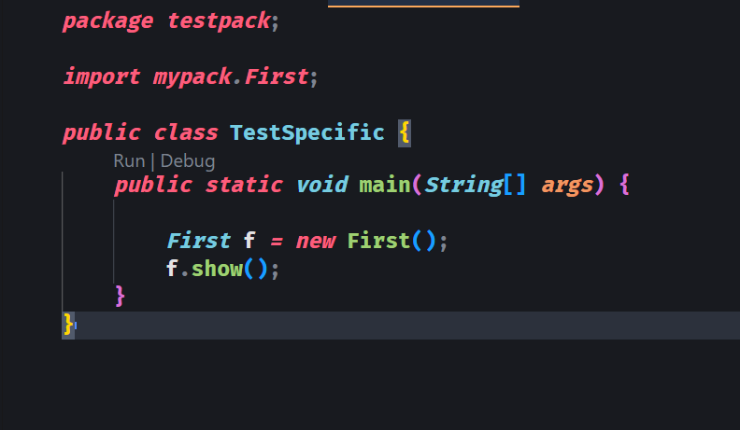

(iii). using fully qualified class name

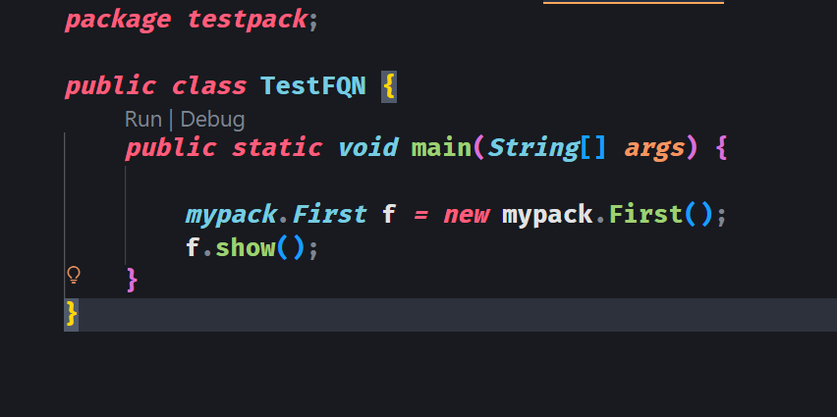

OUTPUT:
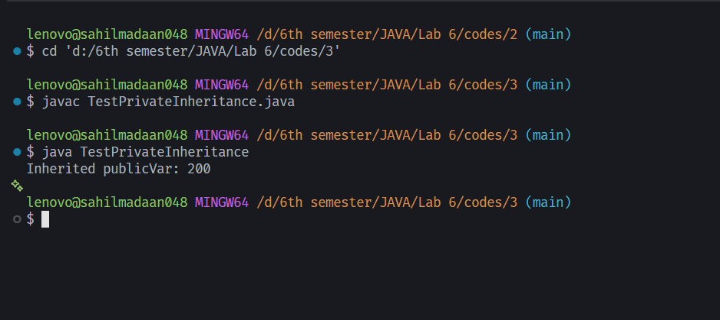

LAB 6
- Write a program to demonstrate that private members are not inherited in a subclass

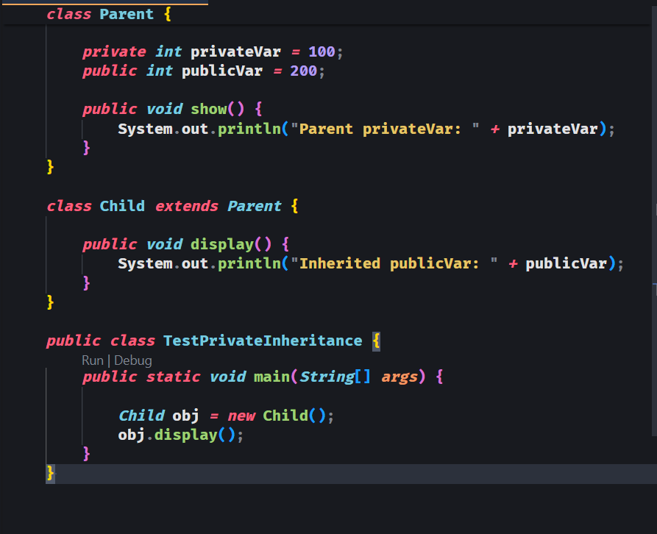

OUTPUT:
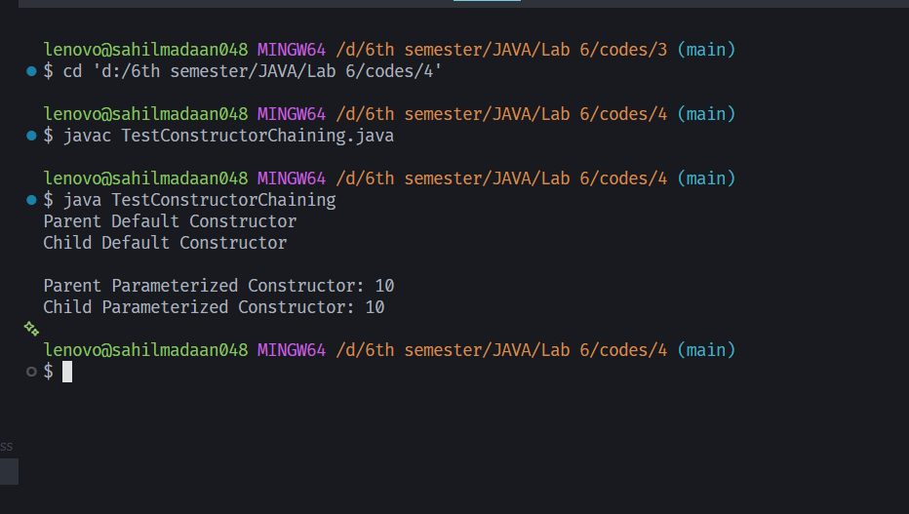

LAB 6
- Write a java program consisting of a parent class and a child class, where each class contains two constructor. Demonstrate constructor chaining such that, upon object creation of the child class, all constructor of both the parent and child classes are invoked

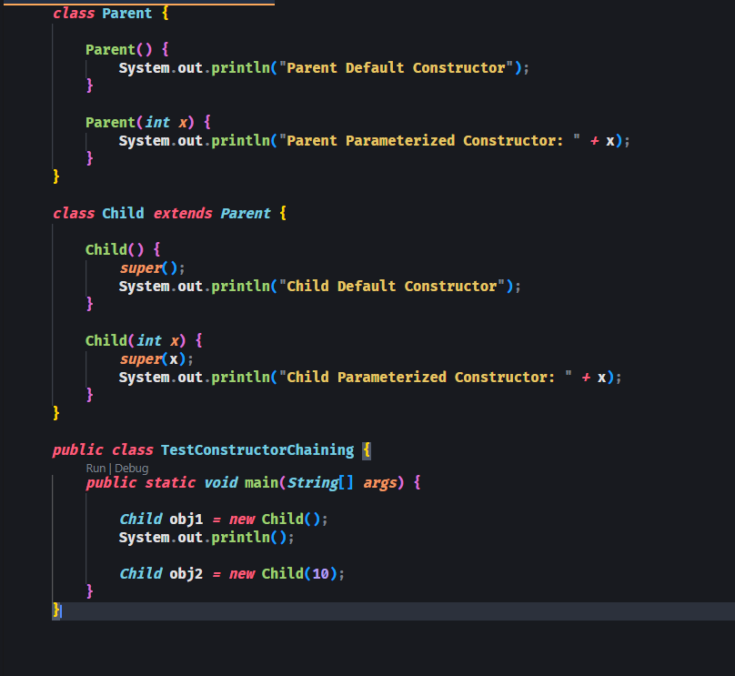

OUTPUT:
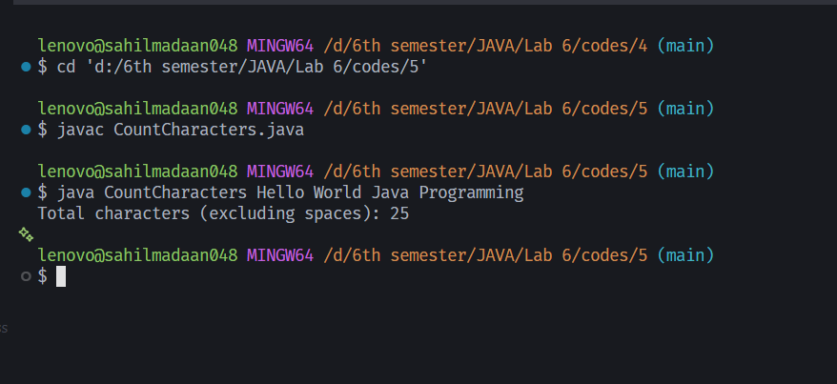

LAB 6
5. Write a java Program that accepts a sentence(group of words) as command-line input. The program should count the total number of characters in all the words excluding spaces

